Smartforms-2
Code:
tables: zpatients.
PARAMETERS: p_patid TYPE zpatients-patid.
data: lt_zpats TYPE table of zpatients,
ls_zpats TYPE zpatients.
START-OF-SELECTION.
select SINGLE * from zpatients into ls_zpats where patid = p_patid.
CALL FUNCTION 'SSF_FUNCTION_MODULE_NAME'
EXPORTING
formname = 'ZDEMO_SF4'
* VARIANT = ' '
* DIRECT_CALL = ' '
* IMPORTING
* FM_NAME =
* EXCEPTIONS
* NO_FORM = 1
* NO_FUNCTION_MODULE = 2
* OTHERS = 3
.
IF sy-subrc <> 0.
* Implement suitable error handling here
ENDIF.
CALL FUNCTION '/1BCDWB/SF00000041'
EXPORTING
* ARCHIVE_INDEX =
* ARCHIVE_INDEX_TAB =
* ARCHIVE_PARAMETERS =
* CONTROL_PARAMETERS =
* MAIL_APPL_OBJ =
* MAIL_RECIPIENT =
* MAIL_SENDER =
* OUTPUT_OPTIONS =
* USER_SETTINGS = 'X'
wa_pats = ls_zpats
* IMPORTING
* DOCUMENT_OUTPUT_INFO =
* JOB_OUTPUT_INFO =
* JOB_OUTPUT_OPTIONS =
tables
it_pats = lt_zpats
* EXCEPTIONS
* FORMATTING_ERROR = 1
* INTERNAL_ERROR = 2
* SEND_ERROR = 3
* USER_CANCELED = 4
* OTHERS = 5
.
IF sy-subrc <> 0.
* Implement suitable error handling here
ENDIF.

Op:
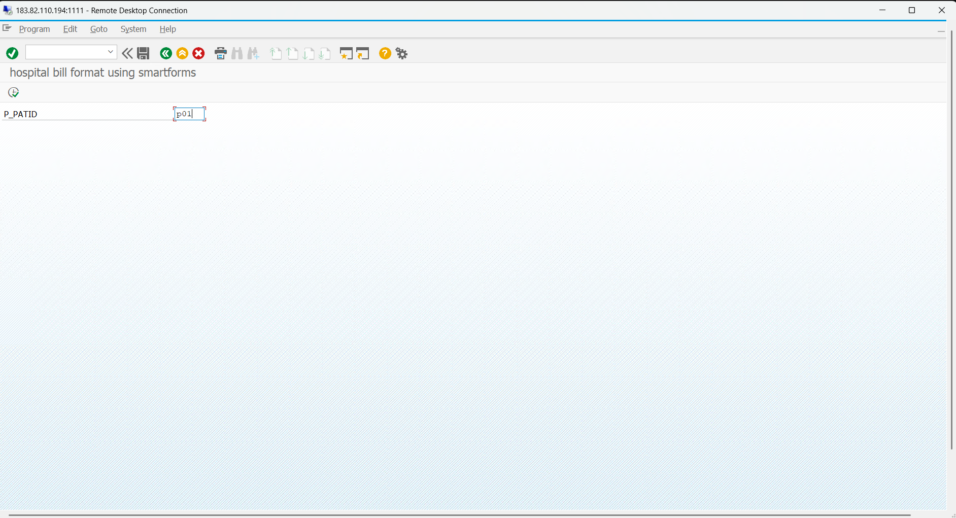
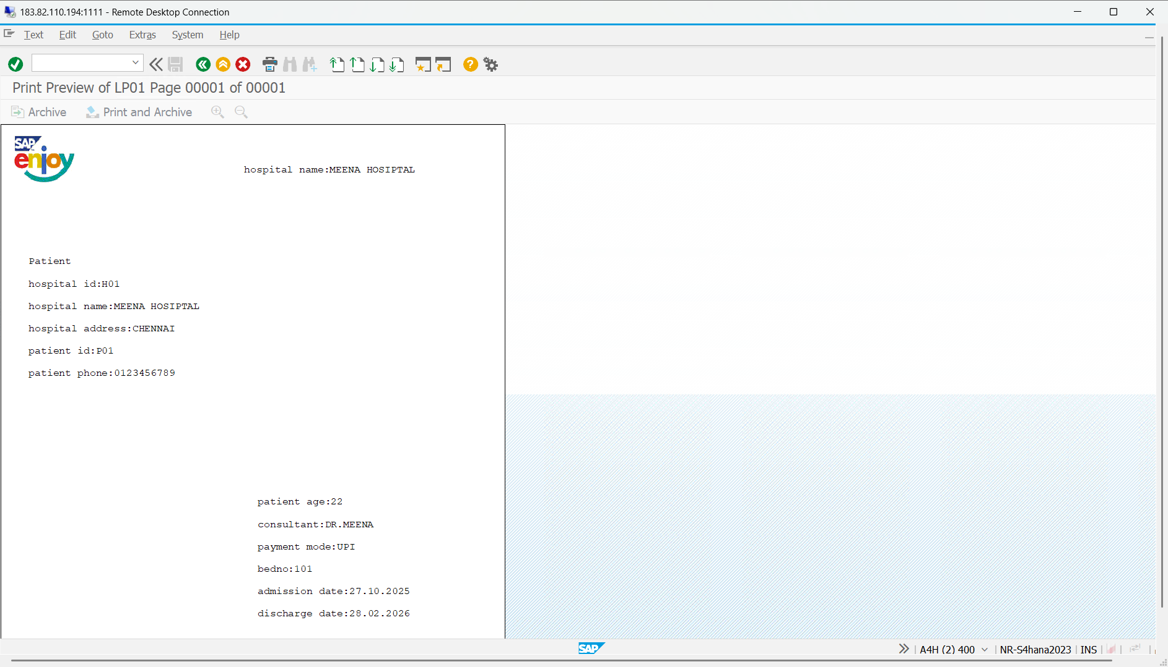
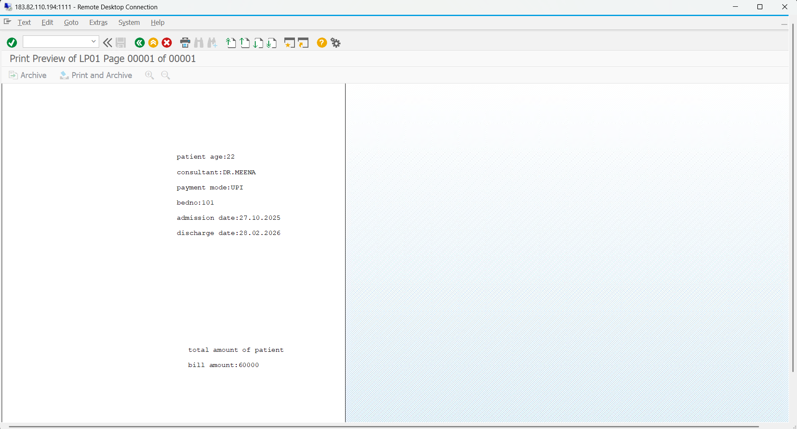
Smartforms:
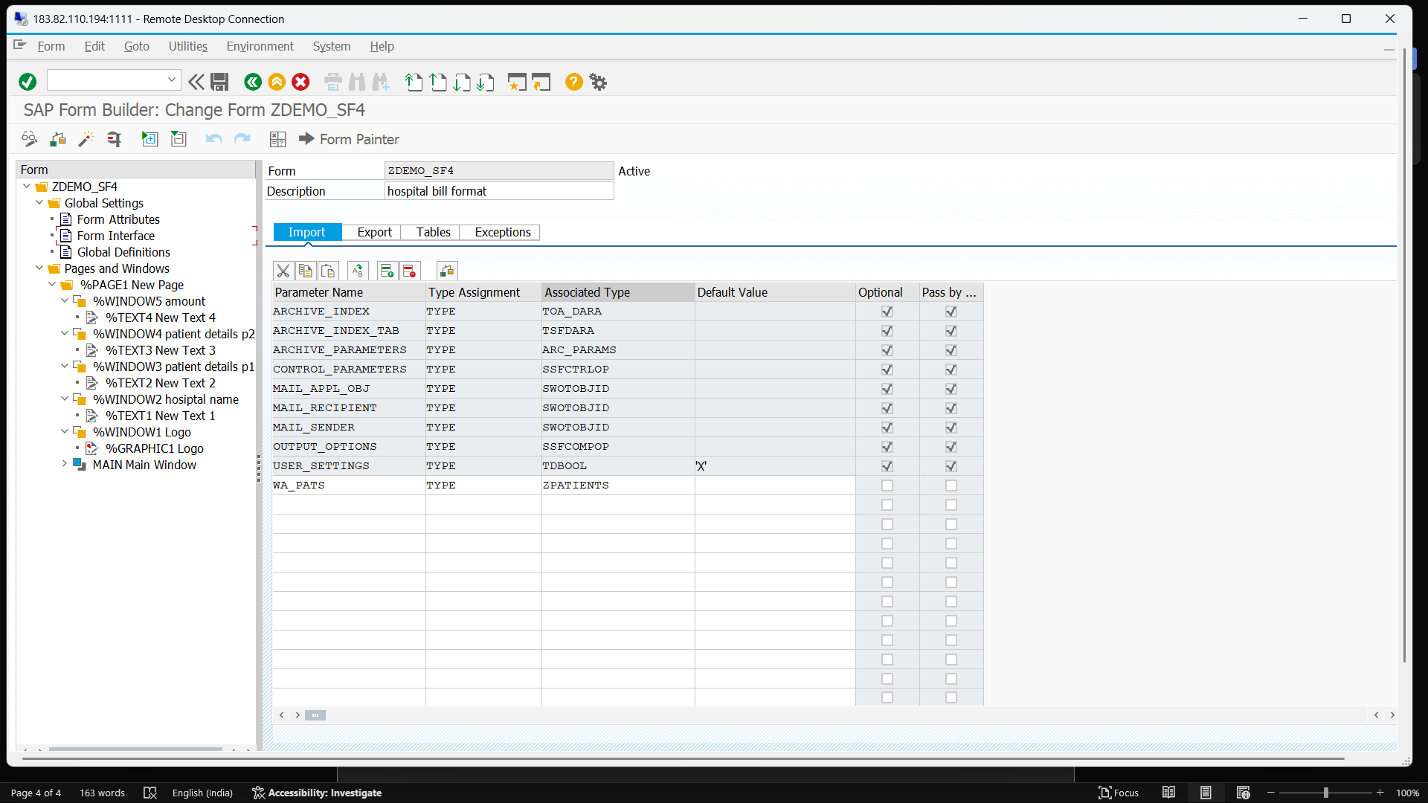

Used Database table:
